

**SMT. CHANDABEN MOHANBHAI PATEL INSTITUTE OF COMPUTER APPLICATIONS, CHANGA**

**Case Study On**

**Hotel management system**

**SUBJECT: Programming Internet-II.**

**SUBJECT CODE: CA213**

**SUBMITTED BY:** Keyur kachhadiya(20BCA025)

Manav Patel(20BCA088)

Deep Gabani(20BCA089)

**BCA Semester-III**

**SUBMITTED TO: Mubina Malik.**

CONTENTS



* **Introduction.**
* In our case study we made on the hotel management and rooms of hotel.
* We have used three concept HTML5, CSS, and java in our case study.
* **Image File.**
* 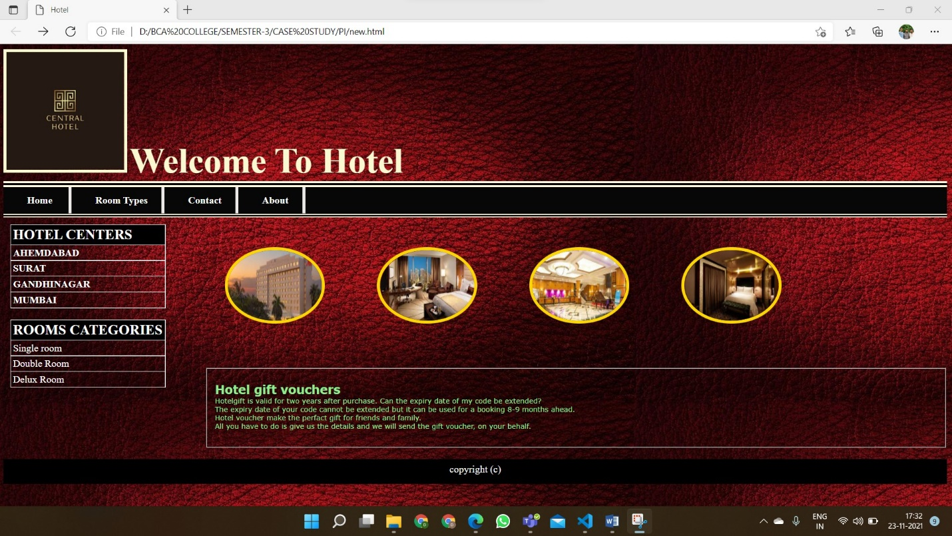**Main page:**
* **Single room: (hyperlink in main page.)**

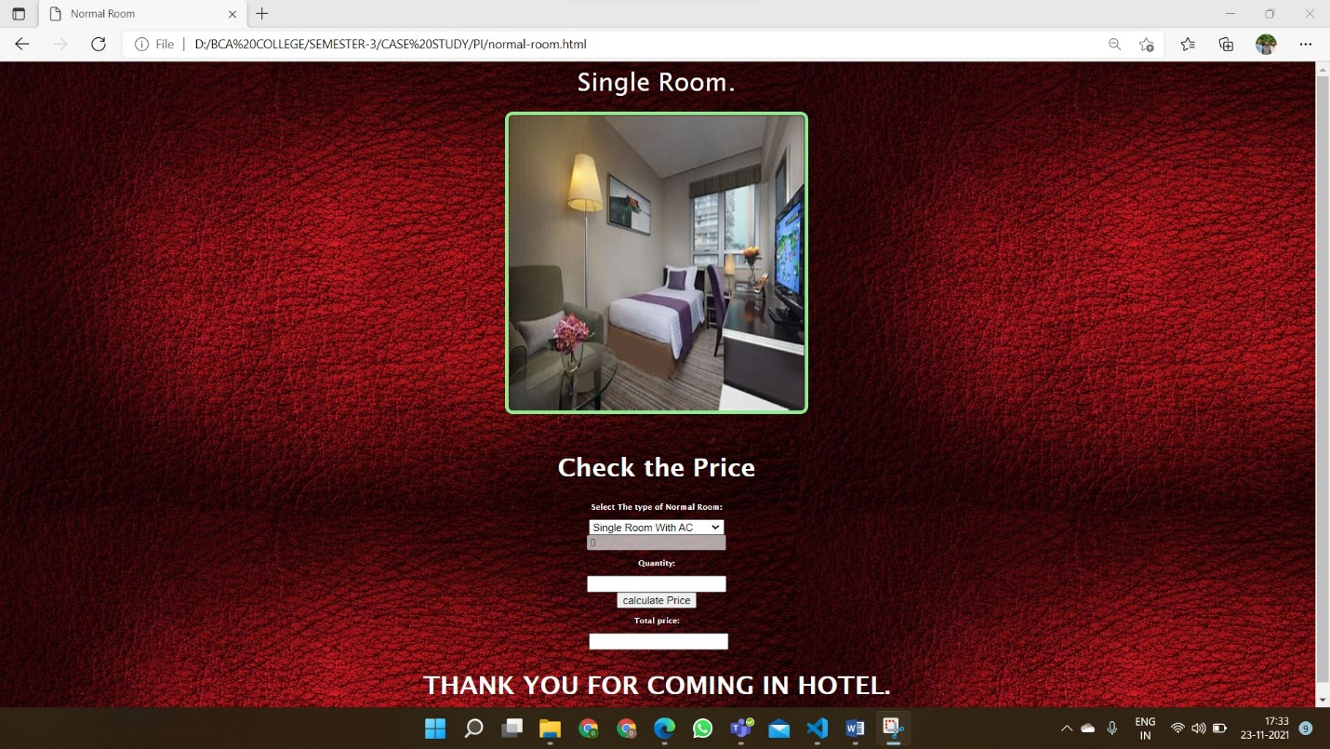

* 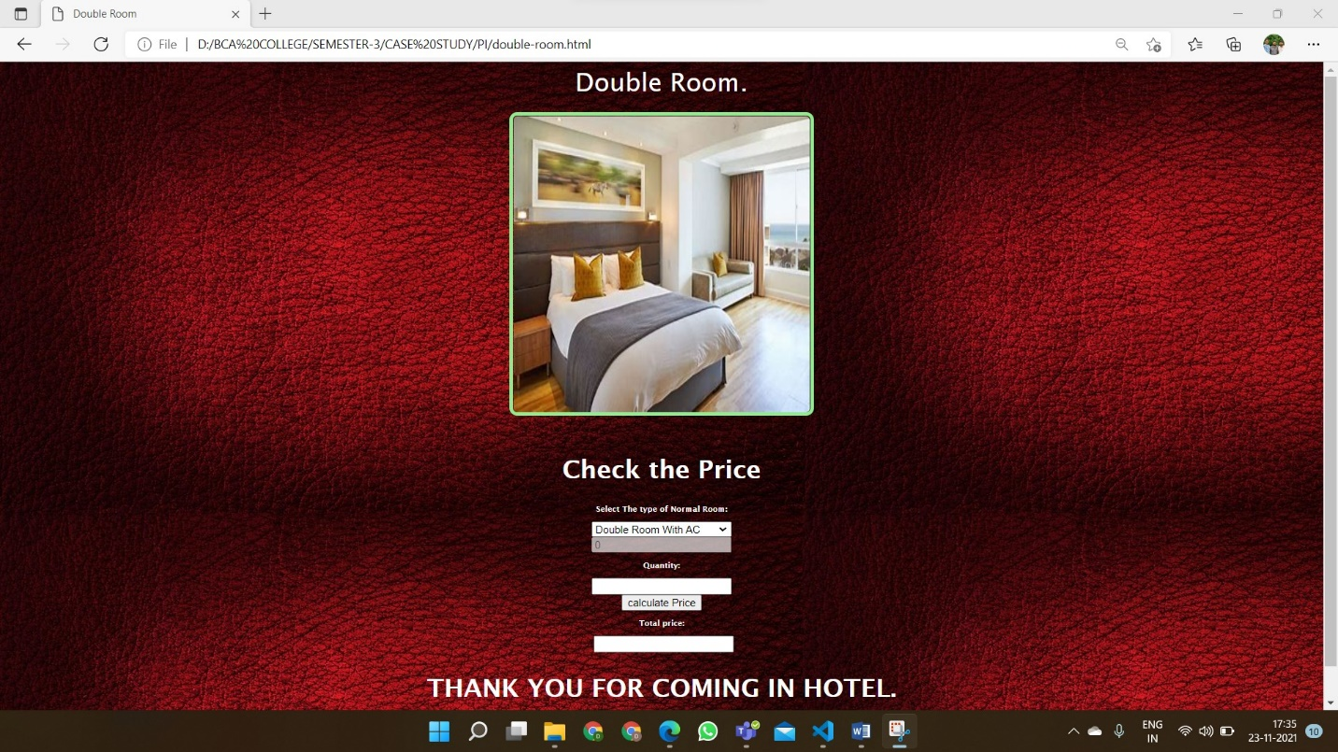**Double room: (hyperlink in main page.)**
* **Delux room: (hyperlink in main page.)**

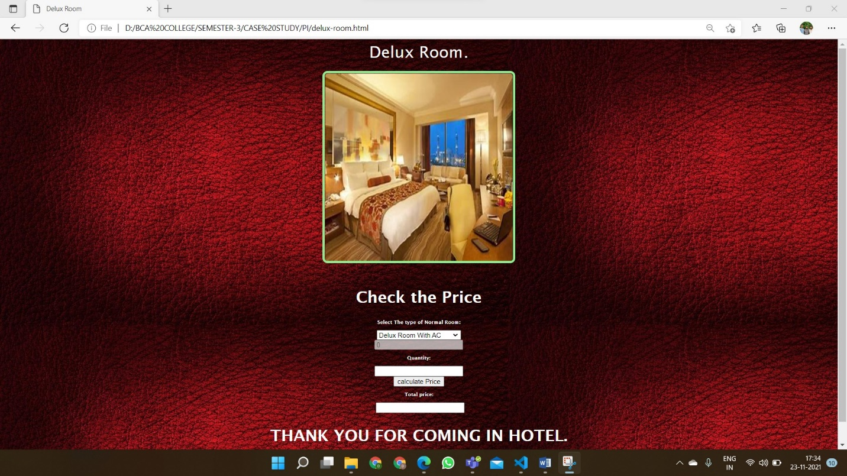



* **Explanation:**
* **Main page:**
  + So first, I have set a background image through img src.
  + After that I have set a Logo of the hotel for that In CSS I have set the height and width, float, border color.
  + Then using a UL tag, created a listed menu part like structure. For Listing we have used LI tag and for editing in the CSS, for main Ul background-color, border and for the text color, alignment of text, size of font, padding etc. has used.
  + Now moving towards images, then total 4 images are there, and for that again use of image src.
  + For gapping between the image the use &nbsp and in CSS witsh, height, border radius, transition, margin and for th effect use of hover in all for images using transition.
  + After that as a look using a paragraph tag, we mention the Paragraph of hotel gift voucher.
  + And at last in main page use of footer at bottom.
* **Hyperlink page:**
  + In the main page there are three hyperlink which is in room category in main page.
  + So for that We have made three pages of single, double and deluxe room.
  + In all the pages first included the background image using img src.
  + After That in all pages we have added the image of room type and have set the border, width, height etc.
  + Now for calculating the room price using java script.
  + Firstly, created the room information using option tag and for showing the default price use on change.
  + Secondly. using a form tag and in that using input element created two text-box of quantity and price in that use of onclick on price.
  + At last, using script tag in that created two function of display and calculate price and in that using getElementById of prioce display onchange is called here. And in the Calculate price also same but onclick means by clicking the calculation should be done. With value of price and quantity is type than the Onclick works and show the total price.
  + These ways in all the hyperlink page is use.

